
HIGH VACUUM STANDARD PUMPING SYSTEMS:
Vacuum Pumping systems are the most reliable and cost-effective means for producing high vacuum. The vacuum pumping systems are trolley mounted for easy movement and has capable of achieving an ultimate vacuum of10⁻⁶ m.bar with Liquid nitrogen trap.
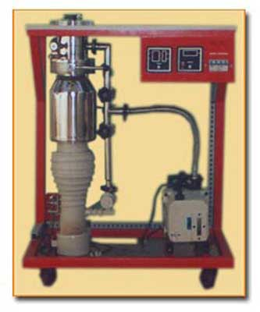
UVS offers many choices of vacuum pumping system, with different pumping speeds for various application, ranges from USP-65D, UPS-75D, UPS-100D, USP- 150D, UPS-225F , UPS-300F and Custom built suitable for the most of the vacuum applications.
The standard Vacuum Pumping Systems consists of UVS Rotary Vacuum Pump, Diffusion pumps and other hardware like valves, baffles, collar, gauge and plumbing lines with Pirani Gauge to measure the roughing and backing vacuum & Penning gauge for measuring the high vacuum. etc.,
TECHNICAL SPECIFICATIONS FOR UPS-100D :
PARAMETERS | DETAILS
Diffusion pump with DC 704 oil | OD-114D diffstak 280LPS (un baffled)
Rotary Vacuum Pump Model:  Speed(Lit/Min.) | URP-15  280 LPM
High Vacuum Valve  - Size (QSV) | QSV-4
Roughing, Backing Valves | QSV -1 – 2nos.
Ultimate Vacuum- mbar (When  Ln2 filled in the Liquid  Nitrogen Trap) | >1.0E -6  with empty, clean & degassed chamber
Inlet Collar Diameter | 114mm
Utilities Required - Power  - Cooling Water at 25o C  at Pr.of 2-3 Kg/Cm2 | 230 V - 50Hz,1 Phase,10 A  2 ltr/min

UNIQUE VACUUM SOLUTIONS
E: nagendrautpath@uniquevacuum.co.in
M: +91 9886726920
P: 080-28367059
A: Unique Vacuum Solutions, #57 8th cross 1st b cross, Doddanna Industrial Estate, Vishwaneedam Post, Peenya 2nd stage, Bengaluru 560091
www.uniquevacuum.co.in
FULLY AUTOMATED HIGH VACUUM STANDARD PUMPING SYSTEMS FOR PRODUCTION APPLICATIONS.
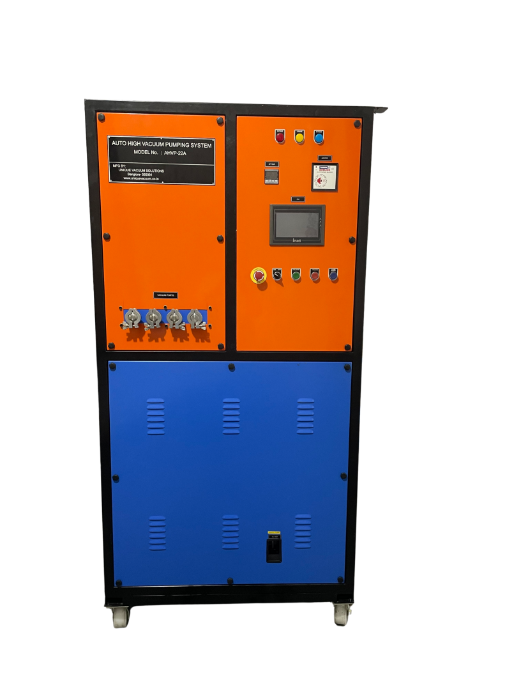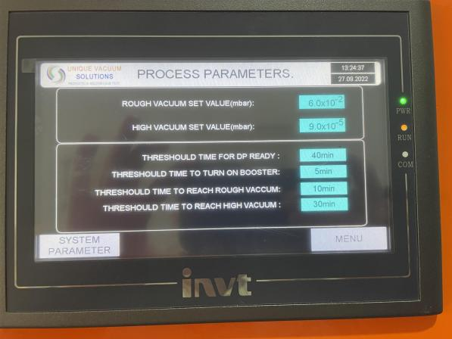
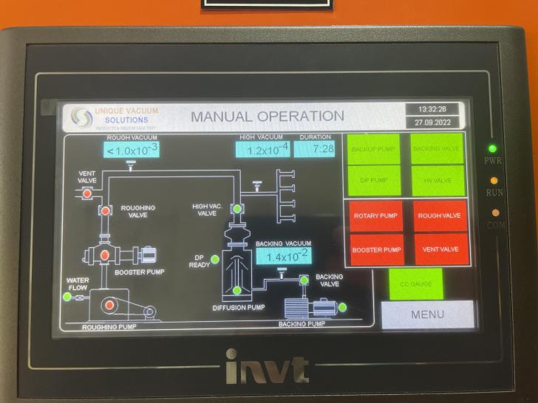
Features :
- setting the desired vacuum and single button operation to achieve at the port.
- vacuum range from 10e-2 to 10e-6.
- auto change over from roughing mode to high vacuum mode.
- auto closure of cycle with load port isolation.
- fully automatic pumps start with all the safety interlocks.
- complete cycle monitoring on the HMI screen.
- data logging of total evacuation cycle.

